Performance Testing
Date | 29 September 2026
Team ID | SWTID-2026-5115
Project Name | Script-Controlled ACL – Restrict Record Access Based on Field Value
Team Members | Shivanii P; Sheerin Farhath; Seshriya; Shalini; Shanthini
Platform | ServiceNow Administrator
Maximum Marks | 5 Marks

Performance Testing
For this project, the available evidence focuses on validating the behavior of the Script-Controlled ACL in ServiceNow. The submitted evidence does not contain a JMeter, Locust, k6, or similar load-test report, so numerical performance metrics such as throughput, CPU utilization, memory utilization, and response-time targets are not claimed as measured results. Instead, the testing record documents the actual ACL/security validation performed in the ServiceNow Administrator.
Step 1: Testing Overview
Field | Details
Testing Tool Used | ServiceNow Administrator – built-in Access Control (ACL) configuration and security-rule verification
Type of Testing | ACL / security validation and functional access-control testing
Target Module / API | Institution Details table and its Access Control rules
Test Environment | ServiceNow Administrator instance
Test Date | 02 October 2026
Step 2: Test Scenarios
S.No | Test Scenario / Description | No. of Virtual Users | Duration | Expected Outcome
1 | Validate that the Institution Details table has the intended ACL configuration. | N/A | N/A | Only authorized access rules are applied.
2 | Verify the ACL required-role configuration for the protected resource. | N/A | N/A | Users without the required role are denied access.
3 | Verify field-value/branch-based condition and advanced scripted condition. | N/A | N/A | Access is evaluated according to the configured condition/script.
4 | Use ServiceNow security-rule verification to validate the configured ACL. | N/A | N/A | The configured ACL is recognized and evaluated by ServiceNow.

Step 3: Performance Test Results
S.No | Metric | Target Value | Actual Value | Status | Remarks
1 | Response Time (Avg) | Not defined | Not measured | N/A | No load-testing tool evidence was supplied.
2 | Response Time (Max) | Not defined | Not measured | N/A | No load-testing tool evidence was supplied.
3 | Throughput (Req/sec) | Not defined | Not measured | N/A | ACL validation was functional/security focused.
4 | Error Rate | Not defined | Not measured | N/A | No load-test error-rate report was supplied.
5 | CPU Utilization | Not defined | Not measured | N/A | No infrastructure monitoring evidence was supplied.
6 | Memory Utilization | Not defined | Not measured | N/A | No infrastructure monitoring evidence was supplied.
Step 4: Observations & Analysis
Key Findings | The ServiceNow evidence demonstrates creation/configuration of the Institution Details table and ACL rules. The ACL configuration includes required-role, condition, and advanced scripted-condition areas. ServiceNow security-rule verification screens were also captured.
Bottlenecks Identified | No performance bottleneck can be established from the submitted evidence because no load or resource-utilization measurements were provided.
Optimization Steps Taken | The implementation uses ACL conditions and scripted logic to control access based on record/field context. The security-rule verification feature was used to validate the configured rule.
Step 5: Screenshots / Evidence
Selected evidence from the team's ServiceNow implementation is shown below. The left panel shows the required role and Branch condition; the right panel shows the scripted access logic and security-rule verification.
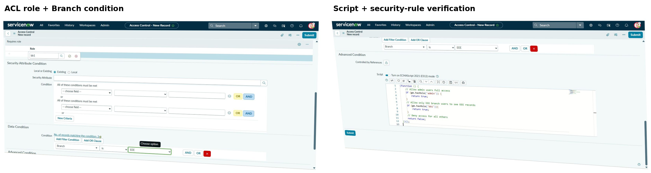
Figure 1. ServiceNow ACL implementation evidence.
Note: This document follows the supplied Performance Testing template while accurately recording the testing evidence available for the ServiceNow ACL project. No unverified numerical performance results have been inserted.

